**Lab Exercise 6**– Terraform Multiple tfvars Files

Objective: Learn how to use multiple tfvars files in Terraform for different environments.

1. Create Multiple tfvars Files:

• Create a file named dev.tfvars:

# dev.tfvars

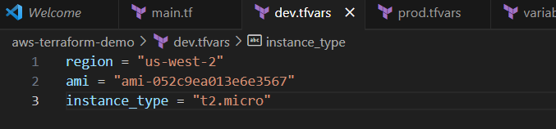

Create a file named prod.tfvars:

# prod.tfvars

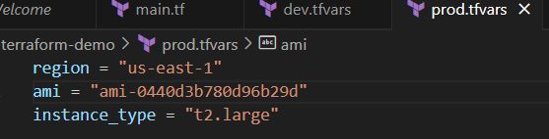

In these files, provide values for the variables based on the environments.

2. Initialize and Apply for Dev Environment:

• Run the following Terraform commands to initialize and apply the configuration

for the dev environment:

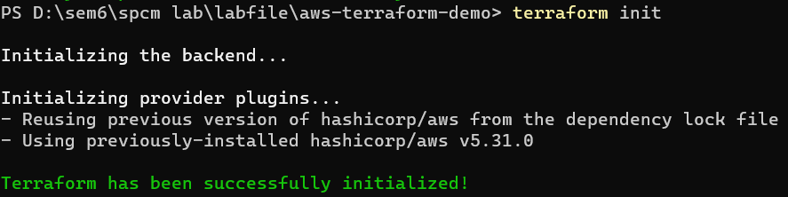

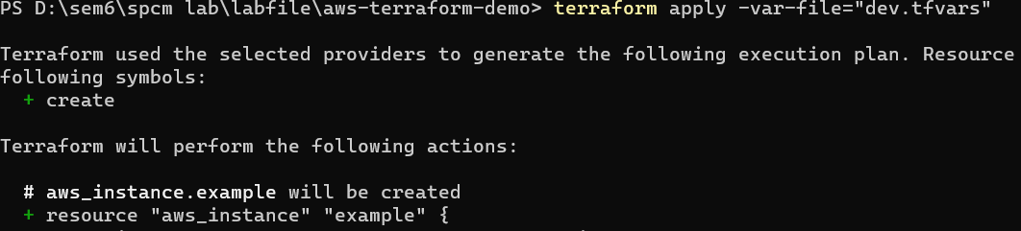

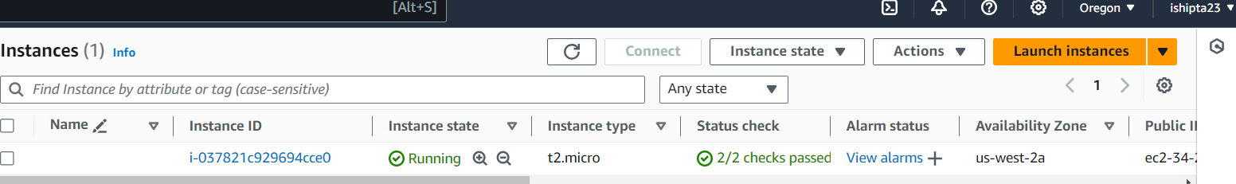

3. Initialize and Apply for Prod Environment:

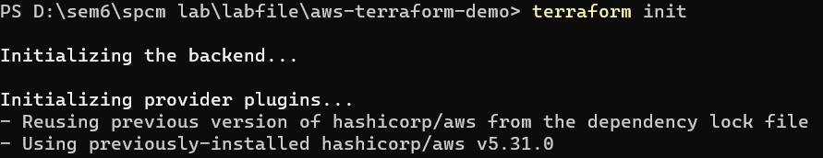



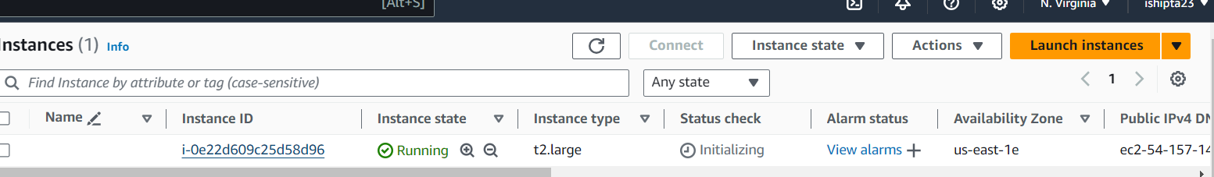

4. Clean Up:

• After testing, you can clean up resources:



